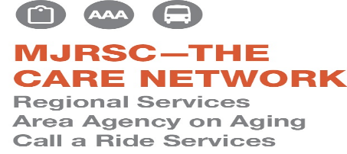
TITLE VI-ADA COMPLAINT FORM

If you would like to submit a Title VI-ADA Complaint to Call A Ride Service, Inc., please complete the form below and return it to:
The Americans with Disabilities Act (ADA) prohibits discrimination on the basis of disability in employment, State and local government, public accommodations, commercial facilities, transportation, and telecommunications. To be protected by the ADA, one must have a disability or have a relationship or association with an individual with a disability.
Title VI of the 1964 Civil Rights Act requires that “No person in the United States shall, on the ground of race, color or national origin, be excluded from participation in, be denied the benefits of, or be subjected to discrimination under any program or activity receiving federal financial assistance.” If you feel you have been discriminated against in transit services, please provide the following information in order to assist us in processing your complaint:
CALL A RIDE SERVICE, INC. MJ REGIONAL SERVICES
DIRECTOR –TITLE VI HR – TITLE VI
25 ROTHERMEL DRIVE 25 ROTHERMEL DRIVE
YEAGERTOWN, PA 17099 YEAGERTOWN, PA 17099
(Authorized designee)
For any further questions, you may call 717-242-2277 or
email cars@mymjrsc.com
- Name of Complainant:

- Mailing Address:
(street)
(city,state,zip)

- Phone:
- (If applicable) Name of person (s) you believe discriminated against you.

- Date of incident:
- Discrimination was based on (please check all that apply):
*Race *Color *Nationality _____ *Origin_____
*Title VI of the Civil Rights Act of 1964
Disability_____Other ____(ADA)
If other, explain:
- Briefly explain what happened and how you feel you were discriminated against. Please include how you feel that others were treated differently than you.

- Why do you believe these events occurred?

- Is there any other information that you feel may be relevant to this investigation?

- How can these issues be resolved to your satisfaction?

- Please list any person (s) who we can contact for additional information or to support your complaint:

Name: Address:

Phone:

- Have you filed this complaint with any other federal, state, or local agency, or with any federal or state court? Yes No

If yes, check all that apply:

Federal Agency State Agency
Federal Court Local Agency
State Court

If filed at an agency and/or court, please provide information on a contact person at that Agency/Court:

Agency/Court
Contact Name: Address:

Phone:

Signature of Complainant Date Filed

